**GRAPHIC DESIGNING**

Graphic designing is a craft where professionals create visual content to communicate messages. By applying visual hierarchy and page layout techniques, designers use typography and pictures to meet users’ specific needs and focus on the logic of displaying elements in interactive designs, to optimize the user experience.

Design is a skill which many companies can acquire, but only the truly gifted graphic design companies will take it to the next level. In an industry as seriously competitive as [graphic design](https://99designs.com/blog/tips/types-of-graphic-design/), it can be difficult to establish a name brand.

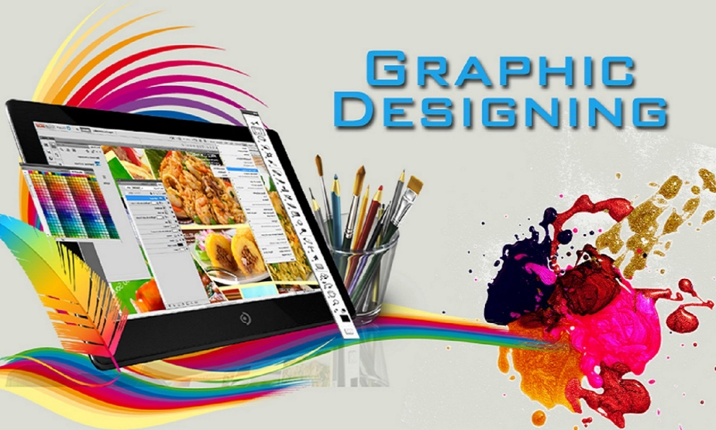

We provide the following types of graphic designs. They are as follows-

* Visual identity graphic design
* Marketing & advertising graphic design
* User interface graphic design

**Visual identity graphic design-**

What is visual identity? Visual identity is a collection of visual elements that serve to represent and differentiate a brand. More specifically, it refers to any visible components such as a logo or brand colours that help customers identify a brand.

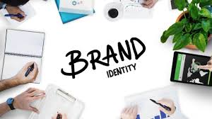

**The purpose of visual identity is**:

* to create an emotional impression on viewers
* to inform viewers about the nature of the brand and services/products offered
* to unify the many different aspects of a business through consistent visuals

**Marketing & advertising graphic design –**

Graphic design in advertising is the use of visual elements to convey a message or promote a product. This includes the strategic use of color, images, illustrations, animation, type, layout, and various printing techniques. At the same time, graphic designers in advertising must consider the needs and goals of their clients to design compelling ads that drive new sales. 

Graphic design is responsible for boosting advertising success, and it does so because of:

* Increased conversions
* Brand recognition
* Effective communication
* Getting attention
* Makes it memorable

**User interface graphic design-**

User interface (UI) design is the process designers use to build interfaces in software or computerized devices, focusing on looks or style. Designers aim to create interfaces which users find easy to use and pleasurable. UI design refers to graphical user interfaces and other forms—e.g., voice-controlled interfaces. 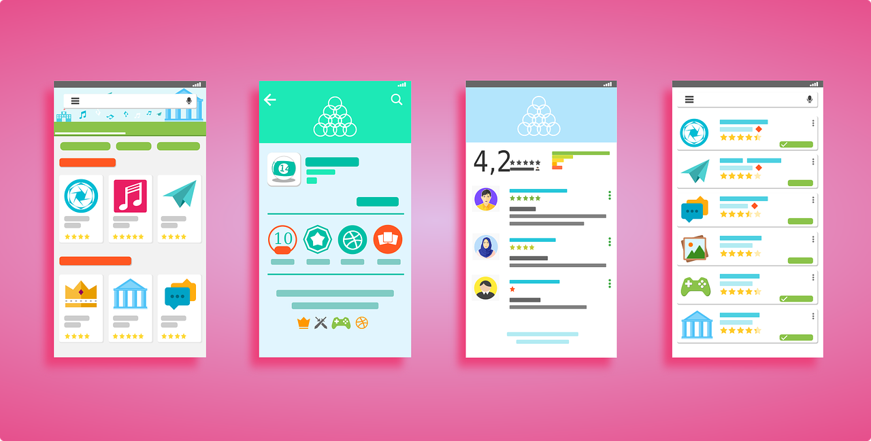

User interfaces are the access points where users interact with designs. They come in three formats:

* Graphical user interfaces (GUIs)—Users interact with visual representations on digital control panels. A computer’s desktop is a GUI.
* Voice-controlled interfaces (VUIs)—Users interact with these through their voices. Most smart assistants—e.g., Siri on iPhone and Alexa on Amazon devices—are VUIs.
* Gesture-based interfaces—Users engage with 3D design spaces through bodily motions: e.g., in virtual reality (VR) games.